//发送验证码

function fsyzm() {

if (checkmobile()) {

if (yzmnum < 3) {

if (checkmobiluser()) {

$("#btnfsyzm").attr("disabled", "disabled");

var query = {};

query.mobile = $.trim($("#txtmobile").val());

query.yzm_des = "登录系统";

var result = getServerData(query, "ds_bm/actions/login_sendVeriCode.xml");

if (result) {

$("#btnfsyzm").removeAttr("disabled");

closezz();

alert("发送成功");

setYzmTimeOut();

yzmnum += 1;

} else {

$("#btnfsyzm").removeAttr("disabled");

closezz();

alert("发送失败");

}

}

}

}

}



此处参数对应html页面上的手机号input输入的值

//判断该手机号的用户是否存在

function checkmobiluser() {

var res = false;

var query = {};

query.mobile = $.trim($("#txtmobile").val());

var result = getServerData(query, "ds_bm/actions/checkmobile.xml");

if (result && result.login_info && result.login_info.cnt > 0) {

res = true;

}

else {

alert("该手机未注册");

res = false;

}

return res;

}

//登录

function userlogin() {

//手机号登录

if (checkmobile()) {

if (checkmobiluser()) {

if (checkyzm()) {

var query = {};

query.mobile = $.trim($("#txtmobile").val());

var result = getServerData(query, "ds_bm/actions/loginmobile.xml");

if (result && result.result.status == "1") {

window.location.href = "register_success.html";

} else {

alert("用户名或密码错误");

}

}

}

}

}

}

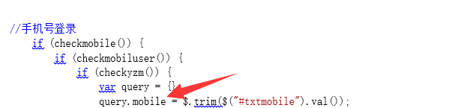

此处参数对应html页面上的手机号input输入的值